**LEBANESE AMERICAN UNIVERSITY**

**USAID – HIGHER EDUCATION SCHOLARSHIP PROGRAM**

**HES - Volunteering Program Verification Form**

This form is to be used to document volunteering hours. If a student volunteers for multiple organizations, a separate form must be used for each organization. **This form must be turned in by the 28th of each month, the latest.**

I certify that the scholar Sary Jabr completed a total of 8 hours of service at Life Sculptor.

The hours were completed hours as per the below:

Hours # 5 (date) _30/09 – 5/10_ (initials of supervisor) __A.K.___

Hours # 3 (date) _7/10 – 11/10_ (initials of supervisor) __A.K.___

Hours # 0 date) _14/10 – 18/10 (initials of supervisor) __A.K.___

Hours # 0 date) _21/10 -25/10 (initials of supervisor) __A.K.___

Brief description of the activities the scholar performed or participated in:

In the first week, i did a research on the importance of emotional resilience in adolescents, the research was divided into nine keypoints, mainly regarding the role of emotional resilience in adolescents development, the role of supportive relationships in building resilience, and how parents / teachers can use strategies to promote resilience. Then, I've transformed these nine keypoints into a PowerPoint that summarizes everything in an educational manner. After that, I developed 8 workshop ideas focused on promoting emotional resilience among adolescents, like strengthening children’s resistance against social media and peer influence, and stimulating of creativity and art in displaying feelings. Lastly in the second week, i did a research in the Innovation Hub Department focusing on the influence of big data analytics on the decision making process in large corporations, the key challenges that large corporations face when leverage data for strategic reasons and how to overcome then, and how does the use of big data in strategic decision making influence   
performance and competitive advantage.

Written feedback about the scholar’s performance:

Sary showcased excellent research and organizational skills, effectively summarizing complex topics into educational PowerPoints. His ability to generate workshop ideas highlights his creativity and focus on practical applications for emotional resilience and big data analytics.

Please rate the overall performance of the scholar at your organization:

|  |  |  |  |
| --- | --- | --- | --- |
|  | Mastery (5) | Proficient (3) | Emerging (1) |
| **Problem solver** | X |  |  |
| **Engaged & Committed** | X |  |  |
| **Open-minded & multicultural** | X |  |  |

Signature

& stamp

__________________________

_

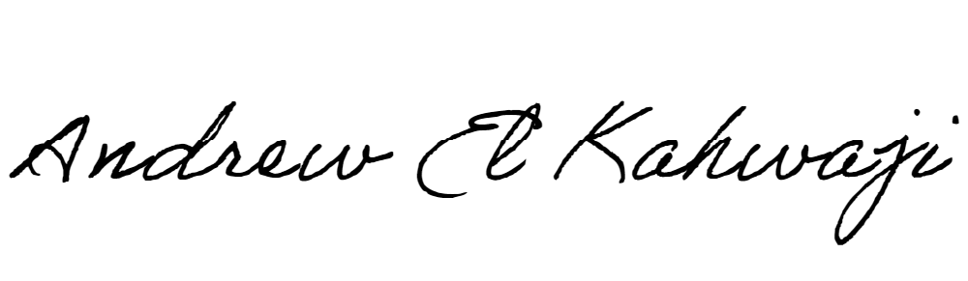

Printed Name _Andrew El Kahwaji_

Date __26/10/2024___

Email __andrew.lifesculptor.coo@gmail.com __

Phone __+961 71 914 378__

**LEBANESE AMERICAN UNIVERSITY**

**USAID – HIGHER EDUCATION SCHOLARSHIP PROGRAM**

